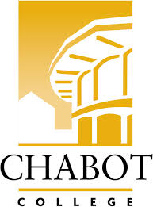**Career Education (CE Committee)**

Chabot College – Zoom

Monday, October 7, 2024

12:00-1:00

**AGENDA**

1. Welcome - Terra
   1. Introductions
2. Information/Discussion Items - Robin
   1. Round 9
      1. Scenarios
   2. Round 8
      1. Projects
3. Good of the Order - Kristina
4. Next Meeting 10/21/2024
5. Adjournment

**Mission Statement**

*Chabot College is a dynamic, student-centered community college that serves the educational, career, job skill, and personal development needs of our community. We provide culturally responsive, revitalizing, and sustaining learning and support services driven by a goal of equity. Building upon students’ strengths and voices, we empower students to achieve their goals and lead us towards an equitable and sustainable world.*